**Submission 2**

We have chosen GDP(per capita) as the development indicator for the second assignment. Due to its ability to gauge a nation's economic performance and standard of living, GDP per capita is frequently employed as a factor in the development index.GDP per capita is calculated by dividing a country's total economic production by the number of citizens living there, and it provides an idea of how well-off each citizen is on average.

A higher standard of life, better infrastructure, more modern healthcare and education systems, and more economic prospects are typically found in nations with higher GDP per capita. The level of development of a nation is frequently gauged by its GDP per capita.

To understand it better, see the attached image,

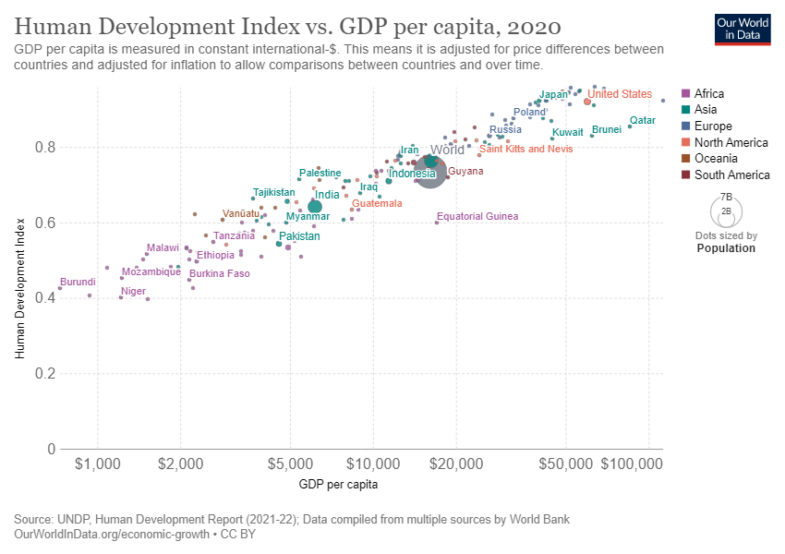

We have taken three indicators namely,

* Manufacturing Value added(% of GDP)
* Urban Population(% of Total Population)
* Inflation Rate
* Export ( as % of GDP)

We implemented 5 models namely with their r2_scores mentioned as follows:

* Random Forest Regressor(0.9947197533167935)
* Decision Tree Regressor(0.97192385358908)
* Polynomial Regression(extension to Linear Regression of degree 2)(0.9056049103274056)
* Deep Neural Network(0.8029407228258991)
* Linear Regression(0.7677681870999598)

We imported train_test_split from sklearn to divide the data into training data(75%)

and testing data(25%).

Data was collected from various reliable sources and then pasted it in Excel sheet from official Datasets of wordbank and government data sites.

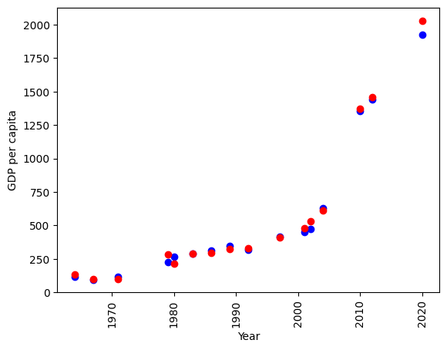

**Graph for Random Forest Regressor**

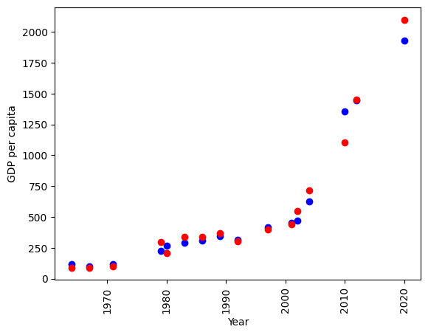

**Graph for Decision Tree Regressor**

**All the models were implemented using Scikit Learn except Deep Neural Network with Adam Optimization AND Mean Squared Error Loss Function Implemented using Tensorflow Library.**

**Random Forest Regressor AND Decision Tree Regressor were best performers whose plots are as shown above plotted using MatPlot Library.**